Objective of the Paper:

Many say that Face Recognition is a solved problem. But the truth is the there is a large amount of gap which exists between the publicly available face recognition systems and the privately available face recognition technology. This work is directed towards reducing that accuracy gap.

Today’s top-performing face recognition techniques are based on convolutional neural net-
works. Facebook’s DeepFace [TYRW14] and Google’s FaceNet [SKP15] systems yield the highest
accuracy. However, these deep neural network-based techniques are trained with private datasets
containing millions of social media images that are orders of magnitude larger than available
datasets for research.

OpenFace uses some constructs both from DeepFace and FaceNet.

General Face Recognition Pipeline:

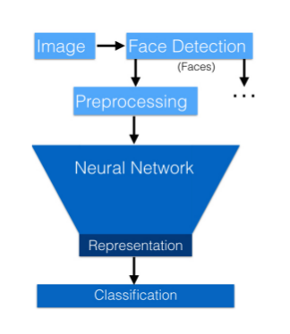
Input --> Face Detection --> Preprocessing --> Low Dimensional Embedding --> Classification.

DeepFace:

DeepFace first preprocesses a face by using 3D face modeling to normalize the input image so that it appears as a frontal face even if the image was taken from a different angle. DeepFace then defines classification as a fully-connected neural network layer with a softmax function, which makes the network’s output a normalized probability distribution over identities. The neural network predicts some probability distribution p̂ and the loss function L measures how well p̂ predicts the person’s actual identity i.

Deepface’s innovation come from the following:
1. The 3D alignment
2. A Neural Network Structure with 120 million parameters.
3. Training with 120 million labelled dataset.

Deepface’s approach to this works because they trained their neural network to do high accuracy classification on their own private dataset. It is difficult to do it outside because of the lack of datasets which give us neat, labelled, clustered images of individuals which classification algorithms can exploit.

So, OpenFace adopts the Triplet Loss function, proposed in FaceNet, to tackle this data bottleneck.

